Name _____________________________________________ ________________/200 points
Alien Poster in Photoshop
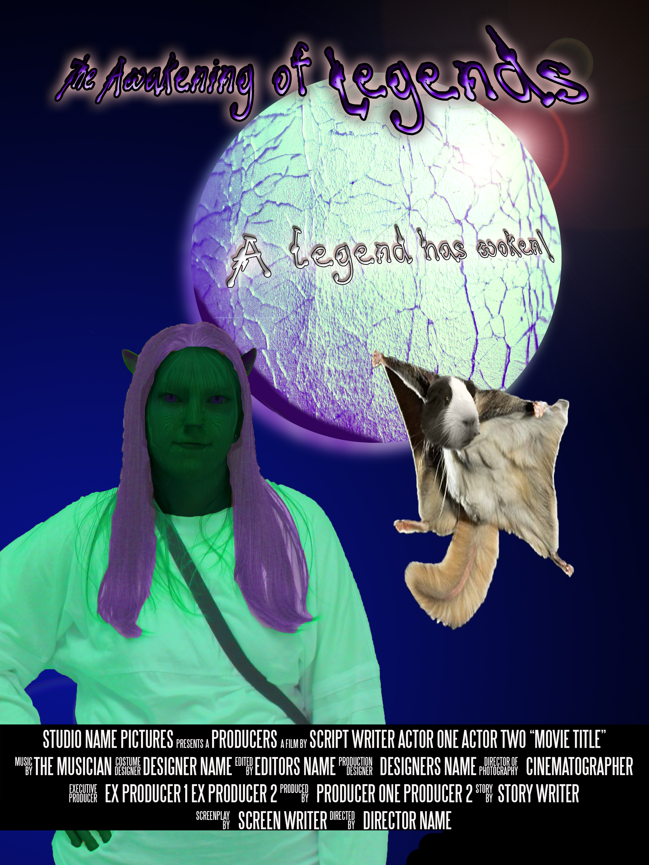
WHAT YOU ARE DOING!
You are going to make a poster that is about an Alien Movie---You are the alien…Copy Alien Poster Folder from Shared Digital Design Folder and add Your last name first initial to beginning. Also install the font provided this will be used for the credits.

Your challenge is to create a poster for a Movie and to bring to life films that don't actually exist! It is about an Alien…YOU!!!
✓ Movie Title ✓ Tagline ✓ Actors Made-up Stage Names at bottom like credits ✓ Rating (ie PG13) ✓ Alien✓ Original Background ✓ Your own planet ✓Your own pet
● The poster cannot contain images or names of actual celebrities, company or studio names, logos or other copyrighted material… No pictures unless they are 90% edited.

You are the director… That is where your name will go.

GETTING STARTED!
✓In Photoshop Folder Name the file: YourLastnamefirstinital AlienPoster
✓The size of the poster must be 18”x 24”
✓ Resolution at least 150 DPI
✓ Paste you picture into a new layer—duplicate it so you have original if you need to start over

Come up with Name of Movie, a tagline and Complete Your Alien (you may need to complete your alien first to get inspiration)… You will need to look at Tutorials 107/54/102 for this..don’t limit yourself to what they give use this as a guide. What else can you do with the liquify? Coloring? Etc. This should take some time.

Make you own Planet—Using Tutorial 58
You as an alien have a pet…it is the unholy of creatures Use Tutorial 13

For your Credits..Use the template provided in the folder. You will need to replace with actual names. You must be the director…Which is the last credit

Look at rubric and go over before turning in.

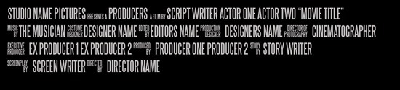
Print to Color Printer….and Turn into Handin…Make sure layers are named… I should see tutorials easily…. You can hide them…but make sure they are named.

Name _______________________________________
Alien Poster

Grading: All will be graded on completeness, effort and time

Creation of Your Alien Tutorial 54/107/ or 102 or combo  This will be based on neatness, effectiveness, time and enhancements using some of the techniques in the listed tutorials This will be a picture of you that you make yourself into an alien. Do you want a different pose? Make sure you transform your whole self. | 0-40 Points
Creation of Unholy creature Tutorial 13 Must look effective. Clean cut and merged together effectively. Use liquify if you need. Make sure this is a high quality image not pixelated. | 0-20 Points
Own Background using brushes Tutorial 265 a Guide. Only use brushes to create your background…no downloaded images. | 0-15 points
Planet Tutorial 58 | 0-20 Points
Credits- Open Credits.psd file YOU MUST BE DIRECTOR. All names must be changed to be actual people.. Effective placed and color etc. | 0-15 Points
Title and Tagline for the movie plus Rating (ex: Star Wars, In a Galaxy far far away… ) PG Use Some type of Type Transformation…(ie on path, transform, character panel etc…. Do not just type this nor use default font and expect to get full credit.) | 0-15 points
Creativity Time and effectiveness of Poster. Look at colors, readability, clarity effort and time you spent on this. Could you do something else to make it better if you have time… | 0-20 Points
Correct size Printed (Make sure you scale to fit before hitting print else it will be tooo big! and Saved to Handin Layers named and put into folders. | 0-10 points

Attach this to back of your poster
Total 200 Points

